An Unforgettable Journey; United, Dad and me
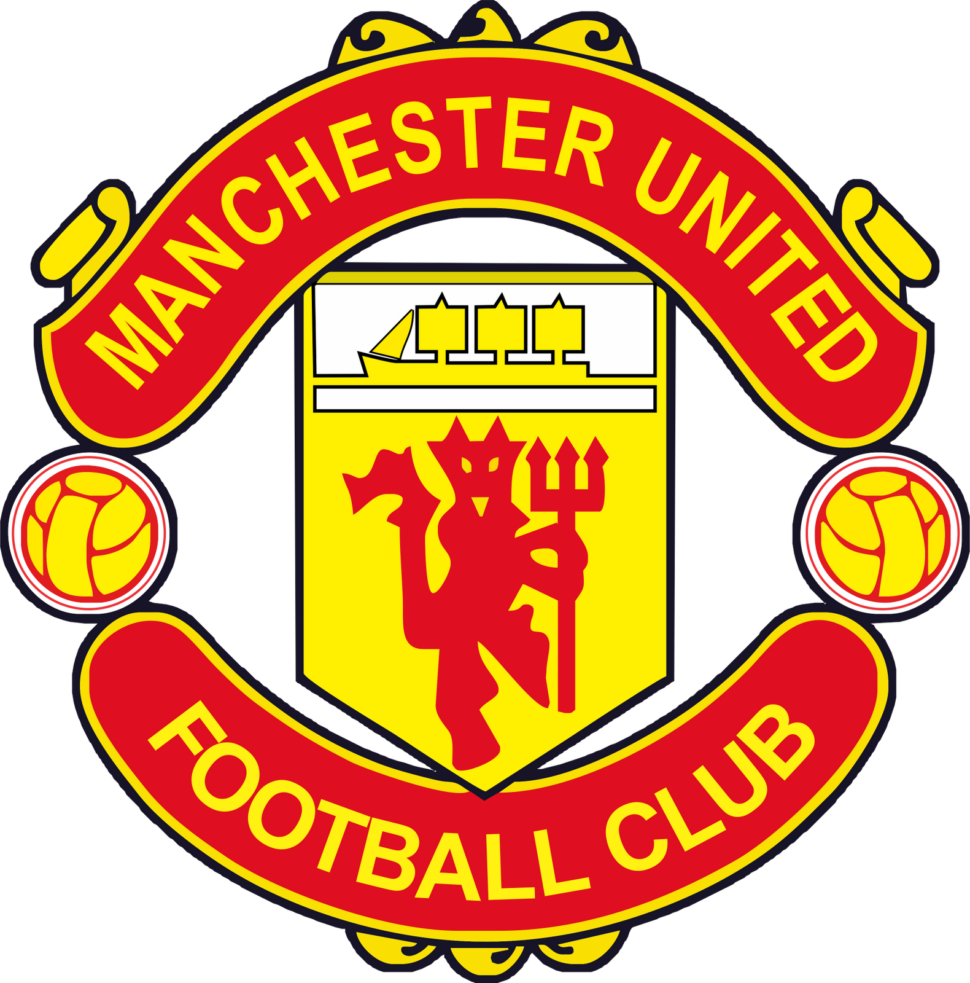

On August 12, 1972, almost 46 years ago, Dad, Grandpa (my Mum’s Dad) and 8 year old me set off for Old Trafford in Grandpa’s old Morris Minor for my very first United match. We were on holiday for most of that summer, after emigrating from England to Canada 4 years earlier, and were staying in Withington, Manchester where my grandparents lived. I recall it being a beautiful sunny day, a rare event in Manchester, even in August! I do remember we parked at Old Trafford Cricket Ground the home of Lancashire County Cricket Club. There are two Old Trafford’s in Manchester (about ½ mile apart) as George Best famously found out, rather awkwardly, upon arriving at Victoria rail station in Manchester on the overnight ferry from Belfast as a shy, nervous 15 year old. He and his mate Eric McMordie were to have a trial with United (a trial is where a schoolboy is invited to train with same age players to assess if they might have any appreciable talents- If they did, they signed on as a schoolboy- e.g. David Beckham signed schoolboy forms at 14 for United). Neither George nor Eric had ever been away from home before. Bestie asked the cabbie to take them to Old Trafford, the cabbie asked “which one?” George must have wondered what he’d got himself into!
But I digress, back to the match; we had tickets for United v Ipswich Town, I was in amazement as we walked towards the ground, taking in all the sights and sounds of the buskers, vendors, religious fanatics with placards announcing the end of the world, and the many food carts with the aroma of fried onions and burgers in the air. There was one particular vendor selling posters of the players, Dad was a Bobby Charlton fan while Grandpa’s favourite was Georgie Best so I got a poster of both of them!
I still have both posters to this day.

Inside the ground, we had terrific seats, almost at the halfway line, in the old Cantilever stand (now demolished). The massive 3 tiered Sir Alex Ferguson Stand now occupies this part of the ground. I remember the colour of the grass, it was incredibly green as it was the first match of the new season. In those days, the pitch would be a mud bath by February, unlike today’s pitches which are kept pristine year round. I still have the programme but unfortunately not the ticket stub from the match, which United lost 2-1. Sadly, they were an aging team in decline at the time, just 4 years after becoming the first English club to win the European Cup.
Two years later, in 1974, United were relegated to the Second Division albeit for just one season. They bounced back to the First Division in style, setting attendance records at most of their matches in ’74-’75.
My Grandpa was a huge United fan also, every time we met up all we talked about was United. I remember when my Nana and Grandpa came to visit us in 1974, in Burlington, Ontario. United were, as mentioned, now in the Second Division (for just one season); Tommy Docherty was the new manager and had let some of the older players go while rebuilding the team with younger players keen to show off their skills and flair on the pitch. Grandpa had brought me a new team poster and I can vividly remember him telling me about each and every new player and how he rated them as footballers.
I was, by now, a United fanatic. United memorabilia adorned my walls (although soon to compete with Cheryl Ladd posters but that’s another story). I had scarves, towels, piggy banks, key fobs, posters, pennants, rosettes, match programmes, old newspapers and books, all of which I would purchase, from money earned cutting grass and walking dogs , in the Souvenir shop which, in the 70’s, was at the back of the old Scoreboard End.
My 2nd match with Dad would occur in March 1976. We had arrived for a 3 week Easter holiday and were met by all the extended family at Manchester Airport (then called Ringway), Unbeknownst to me, Grandpa had somehow been able to get 3 tickets for the upcoming match against Leeds United but had wanted to surprise me once we were back at their house however my Dadcu (my Dad’s father- Dadcu is Welsh for Grandad, pronounced Dadkey) spoiled the surprise and told me at the airport. No harm done, I was still so excited, couldn’t wait for the match. United were now back in the First Division and had a captivating young team, playing fast and attacking football. They were, at the time, sitting 3rd in the league and doing well in the FA Cup. I’m not sure why but my Grandpa didn’t attend this match with Dad and I, instead we went with my Auntie Liz, my Mum’s Aunt. She was supposedly a United fan , however I sometimes had my doubts, as every time I would say to her “United are doing well this season, Auntie Liz”, she would say, in her rich Irish brogue, ‘don’t bother with that lot , kid, they’re a load of rubbish, the lot of ‘em, they’re absolutely shocking! “. Once you got her started it was hard to stop her condemning the club, as she divulged all the latest boardroom transgressions (where she got this information from is beyond me) all the while sat there smoking her Players’ Lights in her tiny flat while we all took turns sticking our heads in her small fridge as she constantly had the thermostat set at 80 F, even in the summer.
I remember a particular time my friend Neil, also a United fanatic, (more about him later) who lived across the road from my Nana’s, was listening to Auntie Liz go on and on about the latest wrongdoings surrounding the club when he quickly turned to Mum, while pointing at Auntie Liz, and asked incredulously “Is she a Red (United) or a Blue (City)?!”
Regarding the Leeds match, I know that we took the bus to Old Trafford from Withington, along with other passionate United supporters who were in full song the entire journey. Every time I went to a match, throughout the years, the anticipation would build once I could see the floodlights, which towered high above the stands. Regrettably they were taken down in 1987 and replaced with lighting which ran along the roofs of the stands.
Arriving at the ground, full to capacity, which in those days was around 58,000, we took up our seats in the K stand, which was a section of the old Scoreboard End, since demolished and replaced with the vast East Stand. My ticket stub from this match is framed and I still have the match programme with my 11 year old handwriting noting the goal scorers and results from the other matches that day. The noise coming from the opposite end of the ground (the famous Stretford End) was incredible as United continuously attacked Leeds (which left gaps at the back in doing so), coming away with a 3-2 win. My own idol at the time, Stuart Pearson, scored which made the day all that much better. The fact that we scored 3 and let in 2 was synonymous with how we played football in those days. I remember this match to be a bit overwhelming, there was so much to take in for an 11 year old obsessed with his football club. Good old Dad even brought his old movie camera and filmed bits of the match. One of the best things about going to a match on a Saturday is watching “Match of the Day” later that night, which shows highlights from many matches plus one match almost in its entirety. I remember watching United’s highlights that night with Dad, Grandpa and the rest of the family. Also, I used to run down to the newsagents at 6 pm to get a copy of the ‘Football Pink’ which was printed on pinkish paper and sold out quickly. The Pink would cover all matches that day, with results, attendance figures, goal scorers, etc.
This swashbuckling young United side made it to the FA Cup Final that same season and were clear favourites to beat 2nd Division Southampton in the final but unfortunately nerves got the better of my heroes and we somehow managed to lose 1-0 on a goal by Bobby Stokes which looked suspiciously offside. I was absolutely devastated as I locked myself in our downstairs bathroom and cried my eyes out. Dad was on the other side of the door trying to console me but to no avail. He tried to suggest that veteran players such as Peter Rodriguez deserved a Cup Winner’s medal; I found out later that Peter Rodriguez was actually Welsh and thus saw right through Dad’s biased reasoning! I guess I eventually came out of the bathroom. Thankfully we returned to Wembley the next season to beat our bitter rivals Liverpool 2-1 in the Final. I was playing in a match myself while the Cup Final was on, Mum was at home listening to the match live on the radio. Dad and I weren’t aware of the score until we saw Mum riding her bike towards the soccer field with a United scarf tied around her bike basket! My best mate on the team, Paul, was a hard core Liverpool fan and realized, at the same time that we did, who had won the Cup as he too saw my Mum ride up on her bike. Oh well, Paul, you did win the League and the European Cup that season!
It would be remiss of me not to mention Dad’s own history with United. Although born in South Wales, he spent most of his upbringing in Whalley Range, Manchester. In those days, you were either a ‘Red’ or a ‘Blue’ (or an Atheist!’) It’s presumably still that way in Manchester. Dad was a passionate Red who loved good attacking football, he first started going to watch United in the late 1940’s when Sir Matt Busby built his first great side, the 1948 FA Cup Winners with the likes of Johnny Carey, Stan Pearson, Jack Rowley, Charlie Mitten, Jimmy Delaney and Johnny Aston (Sr.).
United’s home matches in the late 1940’s were played at Manchester City’s former ground , Maine Road, because Old Trafford had been badly bombed during the war. Dad and his brother Craig would go together to Maine Road although Uncle Craig was more of a City fan in those days. He used to joke that he had to use the back door at the family home in Whalley Range, because he supported City, while Dad went in the front door. Dad was also coaching a local team called St Christopher’s at the time and even got Johnny Aston (Sr.) (former player) to come out and put the lads through their training session once in a while. Dad, by now a season ticket holder, was so incredibly fortunate to be able to watch United in the golden era of the 1950’s, as Sir Matt Busby assembled his famous Busby Babes, with players such as Duncan Edwards, Roger Byrne, Eddie Colman. Mark Jones and Tommy Taylor. Sadly, all of these players mentioned, along with other players, coaches, newspaper reporters, flight crew, and passengers, were to perish in the Munich Air Crash in February 1958.
Mum and Dad both taught me all about the Munich Air Crash right from a very young age. They both told me it was one of those tragic events in life when you remember exactly where you were when you first heard the news. United had to re-build their side quickly as they had lost 8 players in the crash. Welshman Jimmy Murphy, the assistant manager/coach, took over while Sir Matt lay in hospital. Dad always felt that Jimmy didn’t get the recognition he deserved for the way he rebuilt the side while Sir Matt convalesced in Interlaken, Switzerland, after spending weeks in hospital. Dad would often run into Jimmy in Whalley Range where they both lived. Dad was at the emotionally charged first match at Old Trafford after the Munich crash whereupon a team largely made up of youth team and reserve players managed to beat Sheffield Wednesday 3-0 in the 5th Round of the FA Cup.
The programme from this match is worth quite a bit nowadays as United weren’t able to name their team for the match at the time of printing; the United line up in the programme is blank. Dad may have had a programme from this match at some point. I do have one of his programmes from that time period, however, a 4-0 loss to West Bromwich Albion on the 8th of March.

Dad’s highlight match occurred on Wednesday May 29, 1968 when United met Benfica of Portugal at Wembley in the European Cup Final. We were to leave for Canada in just 5 weeks’ time however Dad absolutely had to see United take on the Portuguese Champions before we left England. He drove down to London with City fans, believe it or not, and stood in the West Standing area of Wembley. The ticket stub is framed and the match programme is in very good condition, quite a feat since it’s over 50 years old and that it must have been in Dad’s pocket for the entire match.
The match didn’t kick off until 7:45 pm and went to extra time, with United coming out eventual winners 4-1. Bobby got two, Bestie scored a beauty as he rounded the keeper and local lad Brian Kidd also scored (it was also his 19th Birthday!). It must have been quite late by the time the trophy celebrations ended at which point Dad and his mates headed back up North for their long drive home which, in those days, must have taken about 4 hours.
Knowing Dad, he probably went into work the next day.
United were crowned the Champions of Europe that night as the first English club to win the European Cup.

The next match of note that Dad and I attended was on August 7th 1978, the Centenary match v Real Madrid celebrating the 100 years which United had been in existence. We stood in the Stretford Paddock that evening, adjacent to the Stretford End. The Stretford Paddock was a narrow standing area that ran around ¾ of the stadium right alongside the pitch. Dad and I both preferred to stand which is why I don’t have a lot of ticket stubs; you weren’t issued one when you stood, you just paid at the turnstile and walked in. I remember that Dad really enjoyed this match, not only because United won 4-0, but also because United paraded out some of the players from the past before the kick-off such as the aforementioned Johnny Aston (Sr.), Stan Pearson, Jack Crompton, Nobby Stiles, Harry Gregg, Shay Brennan and many others. Of course, Bobby Charlton (now Sir Bobby Charlton) and Sir Matt Busby received the biggest cheers.
I still have the programme from this match, which has several player’s autographs on the cover; I went to the ground a few weeks later and got autographs as all the players were there to catch the coach for an away match at Leeds.
Incidentally, Stan Pearson ran a post office/newsagents in Prestbury, Cheshire after he retired from football, I remember Dad taking me to meet Stan at his post office in Prestbury in the late ‘70’s. The players didn’t make great money back then and had to get jobs after leaving football. I remember Dad and I had a long chat with him. It’s hard to imagine top footballers today, with regards to what they earn, having to run a newsagents when they retire!

Although this following story doesn’t involve my Dad, I feel it’s worth telling regardless. In August 1979, my youngest sister, Sara, and I went to England on our own for about 5 weeks. We stayed with our Grandparents. I took in some United matches with my pal Neil from across the road, I think we went to about 3 or 4. More importantly, Neil told me one day that he had found out where the great Sir Matt Busby lived. It transpired that he lived on the Kings Road in Chorlton. We set off one morning with our United kits on and armed with pens and books in the great hope that we just might catch a glimpse of Sir Matt.
We took the bus to Chorlton and sat outside Sir Matt’s house for quite a while, I honestly don’t remember how long we sat there, but eventually we saw Sir Matt come out of his house and get into his Mercedes. He drove right past us, at which point we quickly decided to sprint after his car. He must have noticed and pulled over. He rolled down the window and asked what we were up to. We said we were just wanting to say hi and to perhaps get an autograph, if possible. He duly signed our books, asking us our names so as to include them along with his signature. He then asked us what we were going to do now, we said we were going back to Withington. The great man suggested, that since he was going to Old Trafford to do some work, that we might go with him? Before you knew it, we were in the back of the car. Neil and I were so tongue tied, we really didn’t know what to say. We did eventually talk about some of the current United players. We both knew well enough to not ever discuss Munich for Sir Matt never spoke about it. He was very interested in Canada and asked me about the climate, etc. We both just kept staring at him in the rear view mirror as we couldn’t believe this was actually happening.

Once at Old Trafford, which was pretty quiet that day, Sir Matt parked his car and we walked into the stadium with him, with a feeling like we were floating on air. Everyone obviously knew him and stopped to chat with him. Sir Matt, at this point, told us he had some work to do in his office and was there anything else we would like to do? It just so happened that we were very close to the entrance to the famous tunnel which the players ran down on match day onto the pitch (the location of the tunnel in those days was in the South Stand on the halfway line, not where it’s located today). Neil cheekily asked Sir Matt if we could run down the tunnel, Sir Matt obliged and said ‘of course you can, go on then lads’! Which we did, like a couple of lunatics. We didn’t go on the pitch thought, strictly forbidden, even in those days.
When we walked back up the tunnel, Sir Matt was gone, as we had been looking at the pitch and the stands for quite a while. We couldn’t believe how lucky we were and ran almost all the way back to Withington to tell my Grandpa where we’d been and who we’d met. He couldn’t believe it either.
Back to Dad and me, we went to several other matches in the 1978 and 1982 seasons while we were on holiday in the UK. I feel there’s no need to go into detail for these matches, probably because one of them happened to be a midweek 1-0 home loss to Liverpool under the floodlights.
I should mention the players who were particular favourites of Dad’s, throughout the years, a list which included Johnny Morris, Jack Rowley, Duncan Edwards, Dennis Viollet, Paddy Crerand, Sir Bobby Charlton, and , of course, the Welshmen Mark Hughes and Ryan Giggs.

Most of the family went to see United when they came to Vancouver (where we were now living) in May 1982 as United were on an end of season tour. The match was at the old Empire Stadium (now demolished) against the Vancouver Whitecaps of the old NASL. Before the match, we were in the tunnel at the back of the stand as the United team bus pulled up. We watched the players exit the bus and enter the stadium through a door which happened to be right near where we were standing. A family friend gave me and his son a shove and said ‘go on, get in there with them’. I remember just falling in line, without hesitation, right behind John Gidman (United fullback at the time) as he came off the bus. I eventually ended up in the dressing room and made my way towards goalkeeper Gary Bailey whereupon I stressed the importance for them to beat the Whitecaps. I distinctly remember him saying back to me, ‘don’t expect much, lad, we’re on holiday!’

Good thing I was forewarned because United were dreadful, probably because they had just finished a long season in the 1st Division and were also playing on a non-traditional AstroTurf surface. At least I had got all the players to sign my book while in the dressing room.
Ron Atkinson, the United manager at the time, seemed a bit puzzled as to how we got in there. I remember that he kept looking at us. The fact that I was wearing a United shirt that was about 2 sizes too small for me perhaps suggested to Big Ron to just leave it alone and not ask too many questions! I remember he did ask me, however, where I lived; I told him Pitt Meadows, he just kept chewing his gum and staring at me as if he was wondering where the hell Pitt Meadows might be.
I was really upset after the match that United had been so poor and once again, Dad tried to be practical and talk me out of my gloomy mood on the way home. I even took it upon myself to write to my old pal Sir Matt Busby to complain about United’s performance. He wrote back to me and said he was sorry for the poor showing which might have been because some of our best players were involved with England at the 1982 World Cup which was at the same time as the United tour. He did send me a programme to cheer me up though. I have this letter framed.

Dad and I were always trying to find ways to watch United matches. In fact, the day after Tamie and I got married in Hamilton, Bermuda in September 1996 United were playing Juventus in a Champions League match. We had to see the match and eventually found a pub which would show the match. Dad and I walked there in scorching heat to see United unfortunately lose 1-0 away.
Dad and I also used to go to the British Ex-Serviceman’s on Kingsway to watch United matches, in the days when not many matches were on television here.
My final United match live in person with Dad was in Seattle July 2003 when United were on their pre-season tour of the United States. I think there were about 15 -20 of us on this trip, as we watched United beat Glasgow Celtic 4-0. It was a great night, we all drove down in the afternoon, hit a pub or two before the match and then walked to the stadium. We stayed overnight and drove back the next day. Amanda, Dean, Tamie and I then flew to New York to see United beat Juventus 4-1 later that week at the old Giants Stadium in New Jersey.
This past May 19, United were in the FA Cup final v Chelsea. Unbeknownst to us at the time, we had no idea how ruthless the cancer was that was aggressively taking over Dad’s body. We had a feeling that he was in some pain but Dad never let on just how bad it was. Amanda, Dean, Mum, Dad and I watched the match together at Mum and Dad’s. United were really poor that day, in fact so poor that Dad went up to have a nap in the 60th minute because he was fed up with the way they were playing. As mentioned before, United have always played attacking football, right throughout their history, currently, however, they play to a system that is designed to not lose rather than to go all out for the win. Most of us older United fans aren’t happy with this style nor are happy with the current manager, Jose Mourinho. Dad was rather hoping he would have been let go this past season. United ended up losing the Cup Final 1-0 to a Chelsea penalty. This would be my last ever match with my Dad, not a good one to go out on.
Dad would eventually leave us in the early hours on June 19th exactly one month after the Cup Final.
Thank you so much, Dad, for a lifetime of wonderful memories which I will cherish forever. Xx.
I can never thank you enough.
Your loving son,
Gareth
July 2018

